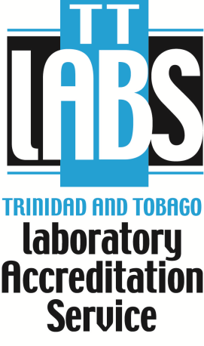
UNDERSTANDING ISO 15189:2012
Date: 2019 April 29 – May 01
9:00 a.m. – 4:30 p.m.
Venue – Maracas Room, PQSL, Trinidad and Tobago Bureau of Standards, 1-2 Century Drive, Trincity Industrial Estate, Macoya.
Registration Form
SECTION 1: PERSONAL DATA

Surname: Click here to enter text. First Name: Click here to enter text.

Job Title: Click here to enter text.
Organization: Click here to enter text.
Work Address: Click here to enter text.
Work #: Click here to enter text. Fax: Click here to enter text. Mobile: Click here to enter text.
Email: Click here to enter text.
SECTION 2: DIETARY RESTRICTIONS
Please choose one (1) of the following: Chicken ☐ Fish ☐ Vegetarian ☐

I am allergic to Click here to enter text.

SECTION 3: PAYMENT DETAILS
Invoice Details

Contact Name: Click here to enter text. Designation: Click here to enter text.

Company: Click here to enter text.

Address: Click here to enter text.

Tel: Click here to enter text. Fax: Click here to enter text.

Cost VAT Inclusive: TTD 2,300.00 Cost per ISO 15189 (required): TTD 1,440.00

TOTAL cost VAT inclusive with standard per participant: TTD 3,740.00

Payment Options: Certified and Company Cheques or via LINX/Cash at the cashier, TTBS, Macoya.

Confirmation of attendance and all payments are to be made two (2) working days before training.

…………………………………………………. ……………………………………………………… ……………………...............................
Participant Signature Signature of Authorizing Officer Company Stamp
Please FAX completed form to 663-4335 (attention Ms Laura Villaruel) OR scan and email to lab.accreditation@ttbs.org.tt

NOTE: For further information you can contact Ms Laura Villaruel at 787-4157, 662-8827 ext. 2248/2247; or email at lab.accreditation@ttbs.org.tt

