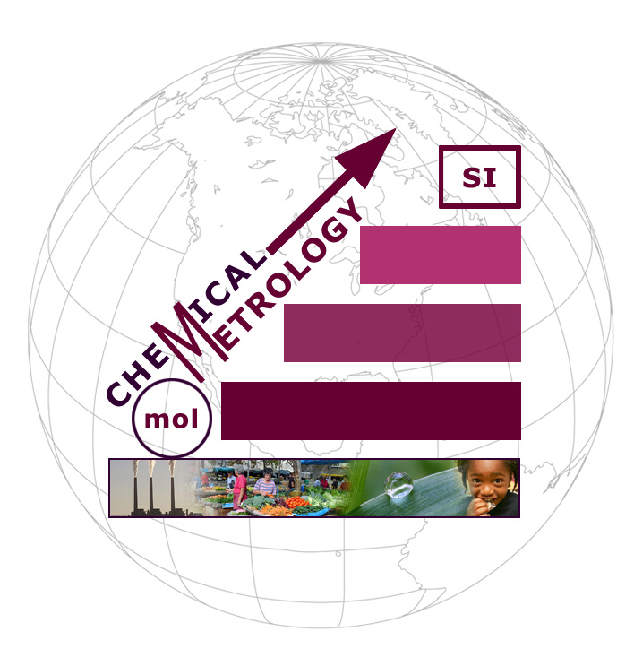
Metrology Division
EMAIL: metrology@ttbs.org.tt FAX: 663-4335

Participant Name……………………………………………………………………………………………………………………………………
Position/ Responsibility………………………………………………………………………………………………………………………….
Company Name……………………………………………………………………………………………………………………………………….
Company Address……………………………………………………………………………………………………………………………………
………………………………………………………………………………………………………………………………………………………………..
………………………………………………………………………………………………………………………………………………………………..
E-Mail…………………………………………………. Fax………………………….……… Telephone……………………………………
PLEASE RETURN (by email or fax) THIS COMMITMENT FORM BY April 10th 2015.
Yes No
I am willing to participate in the May 2015 ERA Hg in Polluted Water PT Programme
I have the support of my organization to participate in this activity
I agree to the terms and conditions stipulated for the participation in this Programme

I commit to payment of participation fees of TT$500.00 (VAT inclusive):
Signature: ……………………………………………….
Position: …………………………………………………
Cash Linx Cheque Please make cheque payable to:-
Trinidad and Tobago Bureau of Standards

